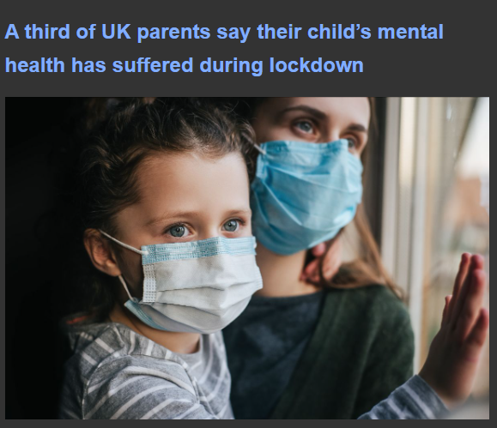
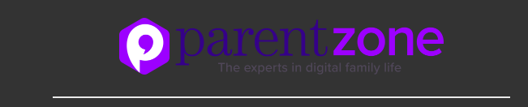
One in three parents (32%) say that their child’s mental health and wellbeing has deteriorated since lockdown started in March 2020, according to new research from Parent Zone.
To help you and your children they have a new app that is totally free and definitely recommended, copy this address for easy access:
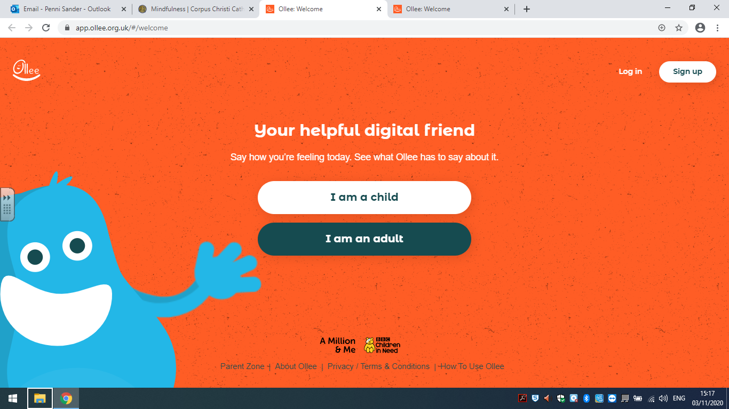
https://app.ollee.org.uk/#/welcome

