How to Draw a 3-D Hand Print 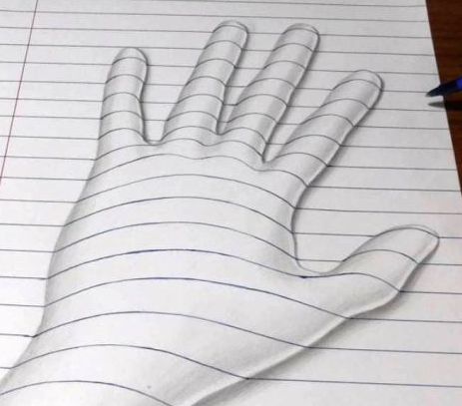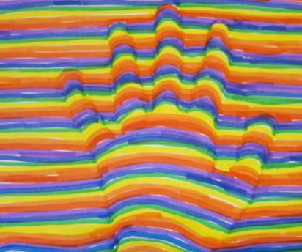
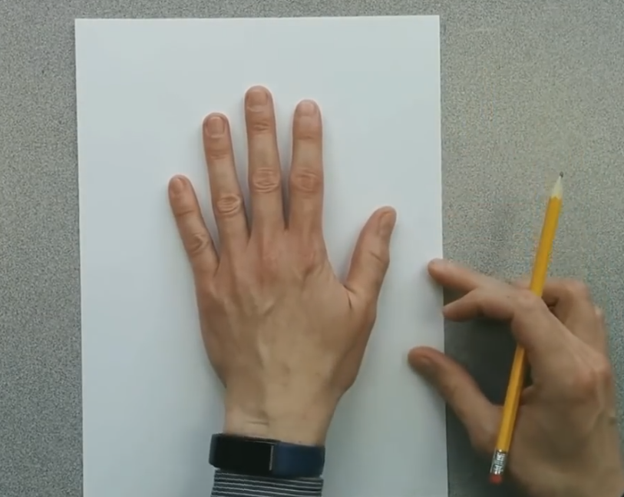
What You Need:
White paper (make it just larger than the hand being drawn).
Piece of scrap paper (not shown) to protect the surface that you are working on.
Pencil.
Colour markers (wider tipped markers work best).

Place the hand to be drawn on the piece of paper.
Make sure that your hand is in the centre and that your fingers are slightly spread.

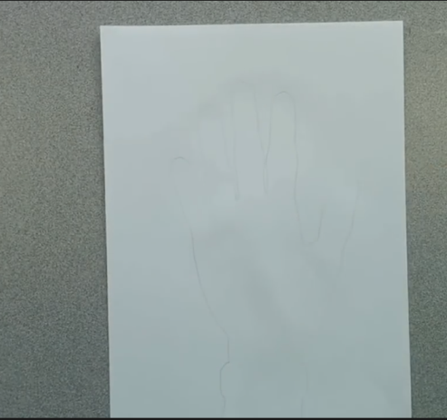
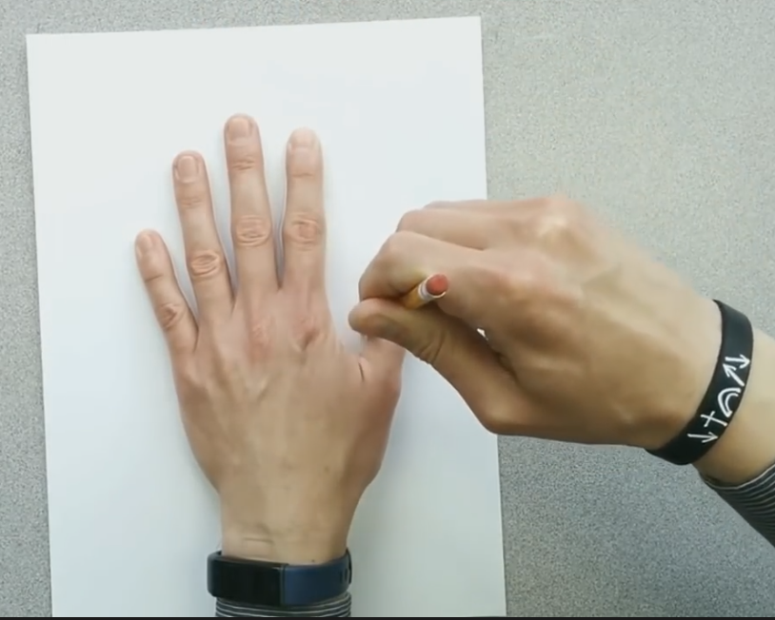

Use the pencil to trace the hand and a section of the wrist.

Choose 3 different coloured markers.
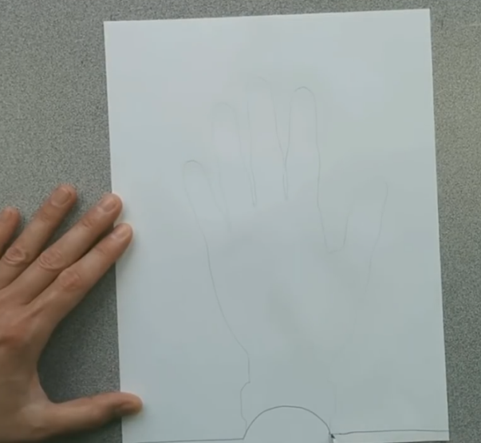
Choosing what order you want to put the colours, start drawing across the width of the paper. Have the next colour right on top of the colour before it. When you finally reach the pencil line of the drawing of the hand, curve the line a little upward in a gentle arc, ending on the other side of the hand line at the same level as you started. Keep adding the curve each time you come to a hand print line. If you prefer you can d this in pencil – especially if you are worried you might make a mistake – and if you do then don’t worry – you can just start again.
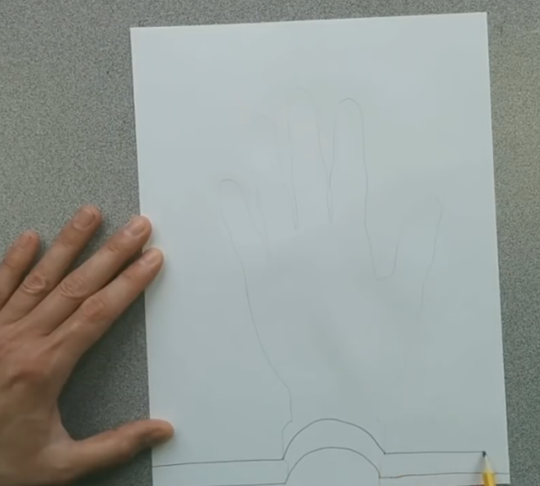

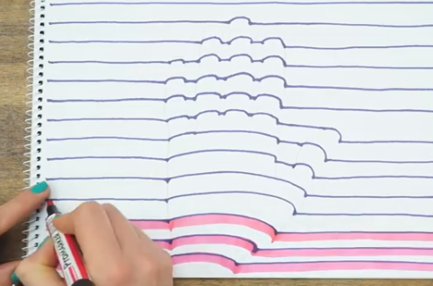
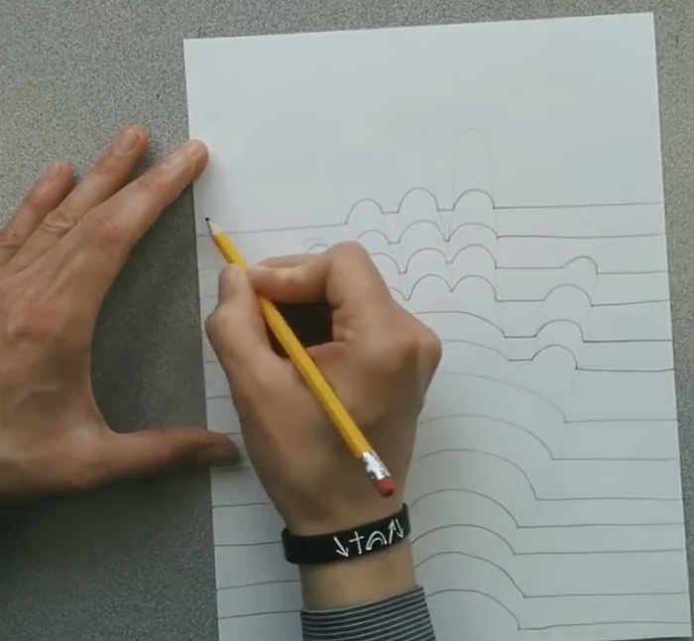
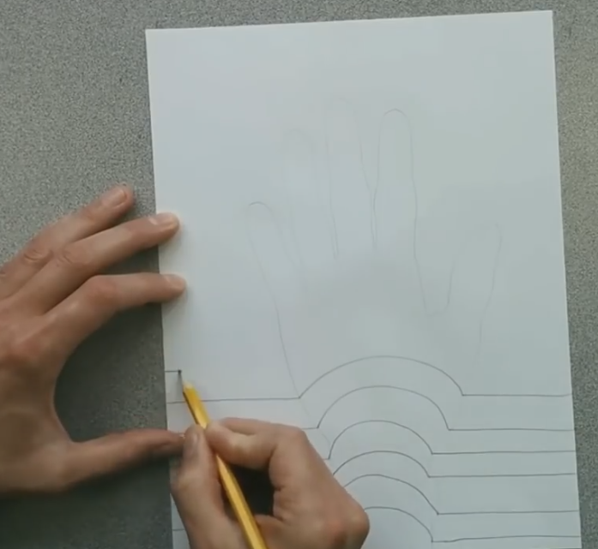
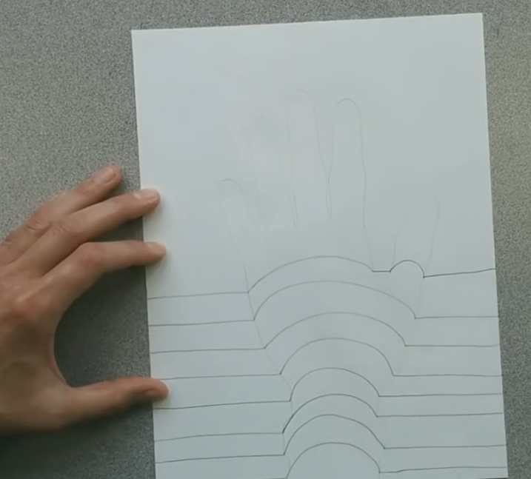

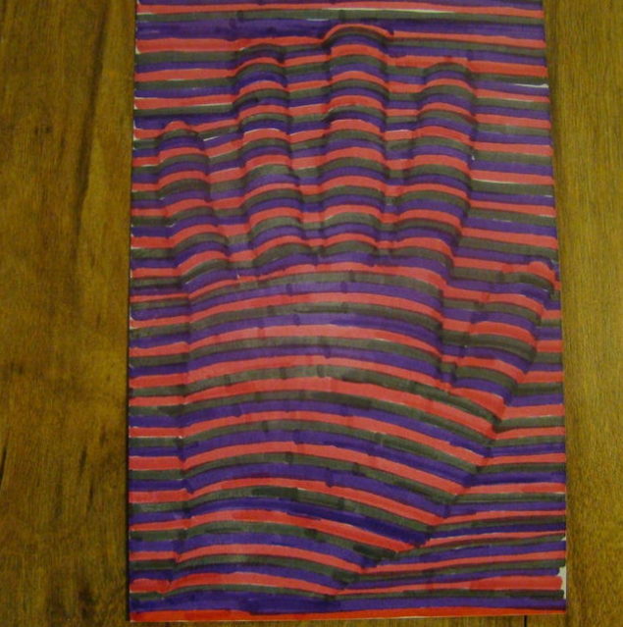
When you are done take a moment and fill in any white paper that is left uncoloured.
Wow that looks great! It looks like a 3-D hand.



